Microsoft Word Accessibility for Document Designers – Examples
The examples in this document are the same examples used in the Section 508 Microsoft Word Accessibility for Document Designers course.
Examples may include a description of why that example is or is not accessible according to the Section 508 Standards.
Lesson 1 does not have examples, so it is not included in this document.

Lesson 2: Links

Inaccessible Example
Instructions for new software:
Click Here
Instructions for old software:
Click Here

Accessible Example
Instructions for new software
Instructions for old software

Lesson 3: Tables

Inaccessible Example
The following table is an image, not a properly formatted table:
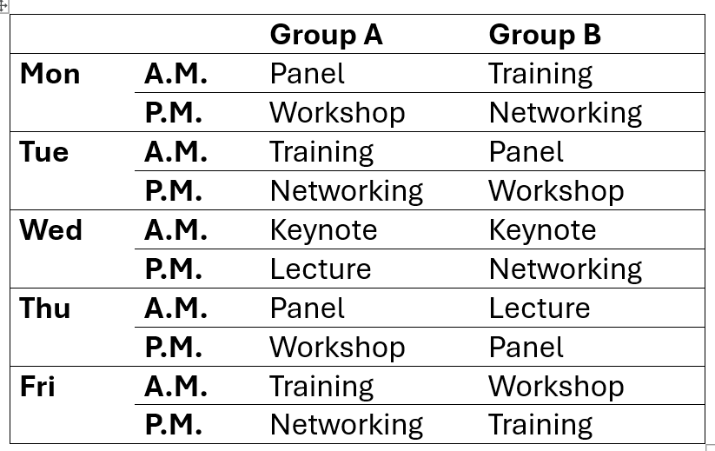
The following table does not have a properly formatted header row or first column. It also contains merged cells, which are inaccessible.
 |  | Group A | Group B
Mon | A.M. | Panel | Training
 | P.M. | Workshop | Networking
Tue | A.M. | Training | Panel
 | P.M. | Networking | Workshop
Wed | A.M. | Keynote | Keynote
 | P.M. | Lecture | Networking
Thu | A.M. | Panel | Lecture
 | P.M. | Workshop | Panel
Fri | A.M. | Training | Workshop
 | P.M. | Networking | Training

Accessible Example
 | Group A | Group B
Mon A.M. | Panel | Training
Mon. P.M. | Workshop | Networking
Tue A.M. | Training | Panel
Tue P.M. | Networking | Workshop
Wed A.M. | Keynote | Keynote
Wed P.M. | Lecture | Networking
Thu A.M. | Panel | Lecture
Thu P.M. | Workshop | Panel
Fri A.M. | Training | Workshop
Fri P.M. | Networking | Training

Lesson 4: Images

Inaccessible Examples
The alt text for the following image should be “GSA logo” instead of “image.jpg”.


The following image should be marked as decorative instead of using a long description for its alternative text. Its position is also set to “text wrapping” when it should be “in line with text.”

Accessible Example


Lesson 5: Inline Objects

Inaccessible Example

Accessible Example

Lesson 6: Columns and Layout

Inaccessible Example
Every child is an artist. The problem is If anything can go wrong it will.
how to remain an artist once we grow up at the worst possible time.
Pablo Picasso. Murphy’s Law.

Accessible Example
Every child is an artist. The problem is how to remain an artist once we grow up.
Pablo Picasso.
If anything can go wrong, it will at the worst possible time.
Murphy’s Law.

Lesson 7: Headers, Footers, and Watermarks

Inaccessible Example
The header of this page says “DRAFT DOCUMENT,” but this text is not accessible in the main content.

Accessible Example
The header of this page says “DRAFT DOCUMENT,” so the same information is duplicated here in the main text:
DRAFT DOCUMENT

Lesson 8: Table of Contents

Inaccessible Example
Microsoft Word Accessibility Overview – Examples 1
Lesson 2: Links 1
Inaccessible Example 1
Accessible Example 1
Lesson 3: Tables
Inaccessible Example
Accessible Example
Lesson 5: Inline Objects 4
Inaccessible Example 4
Accessible Example 4
Lesson 6: Columns and Layout 5
Lesson 7: Headers, Footers, and Watermarks 5
Lesson 8: Table of Contents 6
Inaccessible Example 6
Accessible Example 6

Accessible Example
Microsoft Word Accessibility Overview – Examples 1
Lesson 2: Links 1
Inaccessible Example 1
Accessible Example 1
Lesson 3: Tables 1
Inaccessible Example 1
Accessible Example 2
Lesson 4: Images 2
Inaccessible Examples 2
Accessible Example 3
Lesson 5: Inline Objects 4
Inaccessible Example 4
Accessible Example 4
Lesson 6: Columns and Layout 5
Inaccessible Example 5
Accessible Example 5
Lesson 7: Headers, Footers, and Watermarks 5
Inaccessible Example 5
Accessible Example 5
Lesson 8: Table of Contents 6
Inaccessible Example 6
Accessible Example 6

